Forecasting Diabetes Healthcare Costs & ROI Analysis in India

Executive Summary
This project applies health economics and data analytics methods to forecast diabetes-related healthcare costs in India and evaluate the return on investment (ROI) of a hypothetical preventive intervention. Using historical expenditure data, time-series smoothing, and regression-based forecasting, the project produces policy-relevant economic insights.

Disclaimer
The data is realistically altered to maintain confidentiality and data privacy regulations. This study has been conducted with aims to appreciate socio-economic considerations that play a part in determining economic viability and intervention’s financial claim legitimacy. This study does not intend to infringe upon copyrights of any institution, establishment or governing agency, nor does it claim accuracy of its findings. This study is all but an aim to showcase a glimpse of statistical and analytical prowess that goes into approving a health treatment option with context beyond improving patient treatment outcome, factoring in financial variables. This report is a synthesis of the methods and self-deduced interpretations of results generated through the enlisted methods while upholding strict data management and privacy practices. This report recognizes the nuanced nature of real world setting, the variables that need accounting for and equitable representation, admitting its consequent limited accuracy. However, the study aims for the readers to appreciate the analysis that encompass the monetary side of things, a glimpse of what actually goes into deeming whether an intervention is worth economically at a national and global scale.

Project Objectives
- Forecast diabetes-related healthcare costs
- Apply moving averages to smooth trends
- Model a preventive intervention
- Estimate ROI
- Produce policy-ready outputs

Background and Rationale
Diabetes represents a growing economic burden in India and around the world. Health economic forecasting and ROI analysis help policymakers allocate resources efficiently.
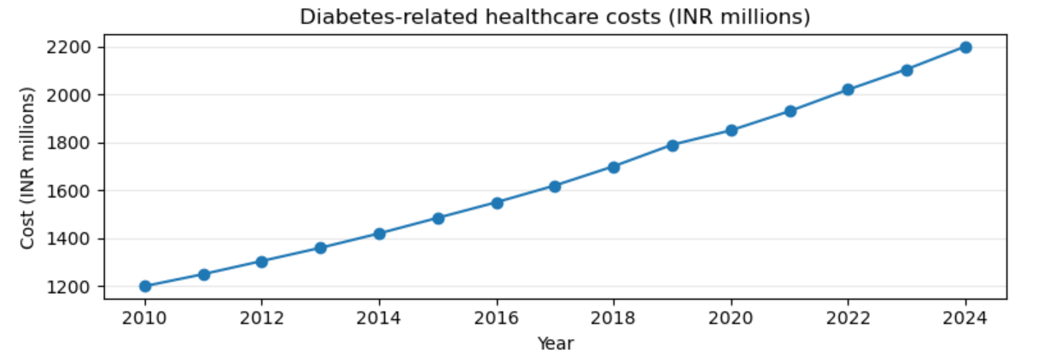

Data Sources
Historical diabetes healthcare cost time series (CSV)
Hypothetical intervention assumptions
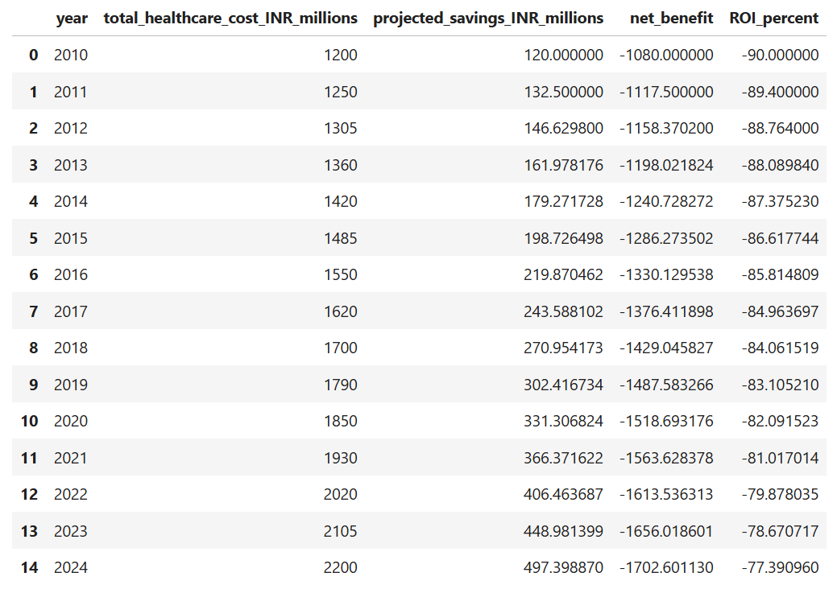

Methods
Data realistically fabricated drawing inspiration and subjecting anonymized data to robust cleaning protocols, moving averages, regression forecasting, and ROI modelling were conducted using Python.
- Data Preparation
Imported historical cost data using Python (pandas) Checked for missing values and inconsistencies Ensured consistent units and time continuity
- Trend Smoothing
Applied a 3-year moving average (MA3) to stabilise short-term fluctuations Enabled clearer interpretation of long-term expenditure trends

- Forecasting
Used regression-based forecasting to project healthcare costs for the next 10 years Forecasts provide a baseline scenario for economic evaluation
- Intervention & ROI Modelling
Modelled a preventive intervention reducing projected costs Calculated annual savings Estimated ROI using: ROI= Programme Cost Savings−Programme Cost Negative ROI values reflect common short-term trade-offs in preventive health economics.

Results

Forecast Table

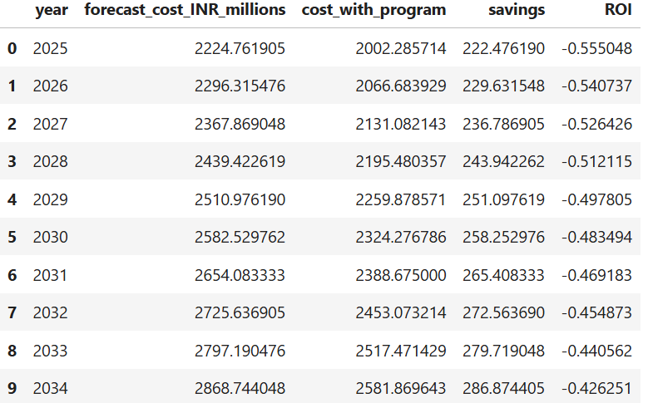

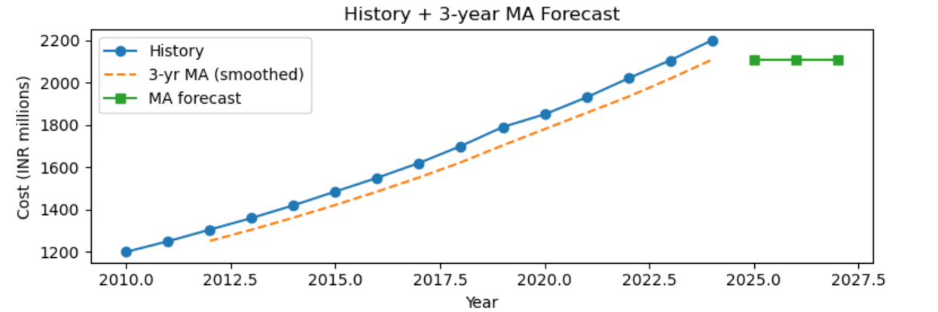

Figures/Plots

Forecasted vs Intervention Costs (forecast_plot.png)

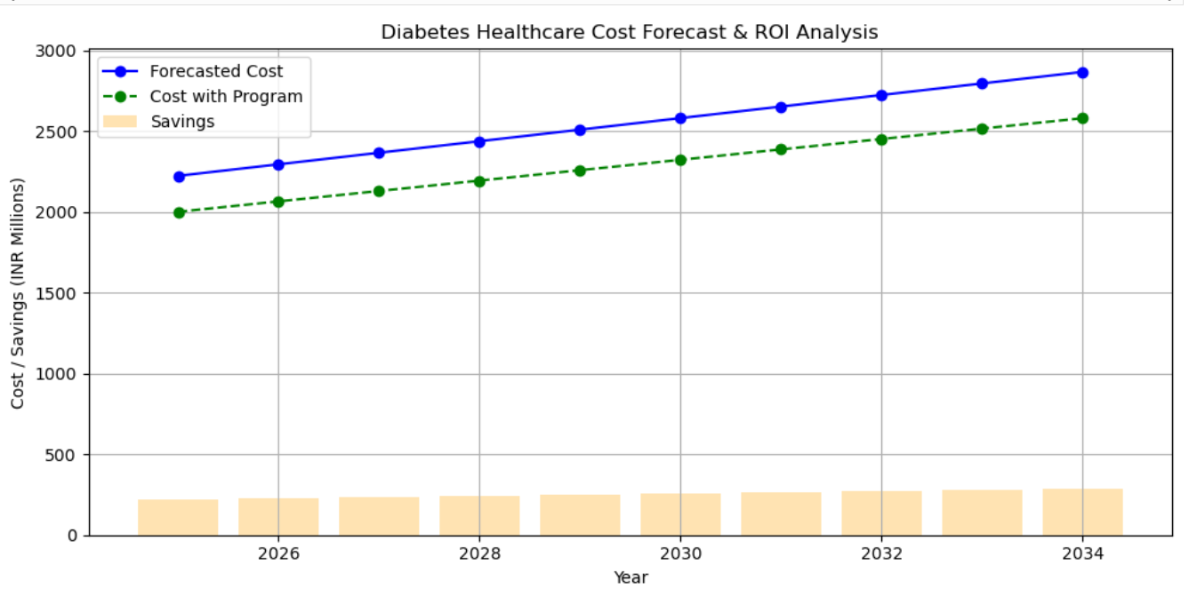

ROI & Annual Savings Visualization (forecast_roi_plot.png)

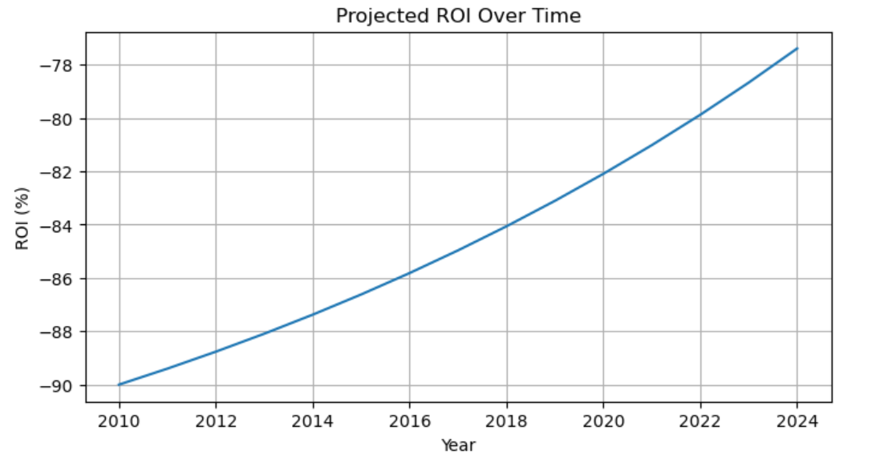

Discussion
Results indicate rising healthcare costs and demonstrate the economic trade-offs of preventive interventions.
- Economic Implications
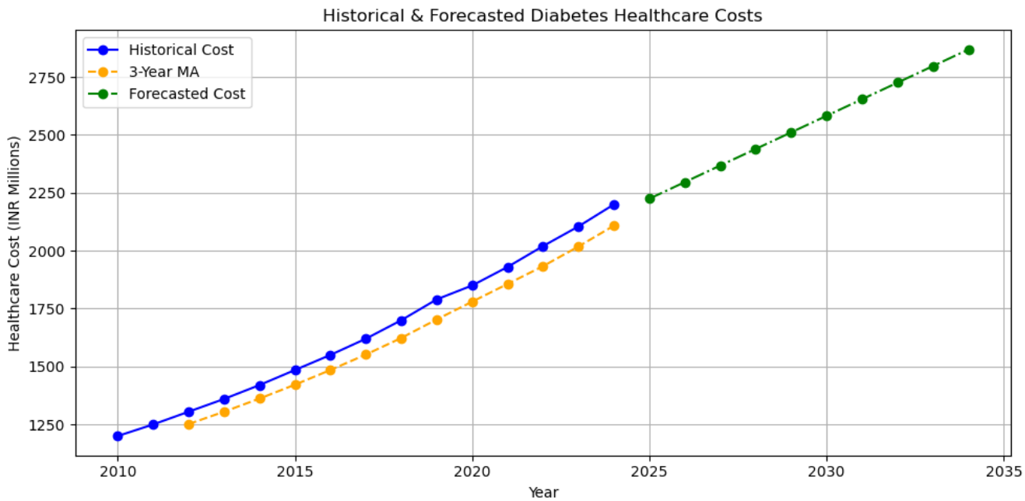
- Preventive intervention may significantly reduce healthcare expenditure and improve budget efficiency.
- ROI analysis demonstrates the value of intervention investment relative to savings.

- Limitations
- Intervention assumptions are hypothetical.
- Only total costs considered; no stratification by age, gender, or region.
- Does not account for indirect costs, comorbidities, or future inflation.
- Future Improvements
- Include cost-effectiveness per QALY for more comprehensive analysis.
- Incorporate age- or region-specific forecasts for targeted policy insights.
- Perform sensitivity analysis on intervention parameters.

Conclusion
- Developed a reproducible workflow for forecasting diabetes healthcare costs.
- Modelled a preventive intervention scenario and calculated ROI.
- Produced visualizations suitable for policy decision-making.

Software and Tools
Python (pandas, numpy, matplotlib), Jupyter Notebook, Excel, GitHub

